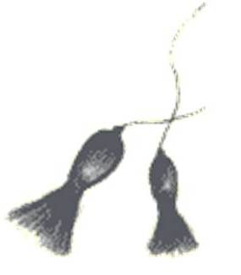

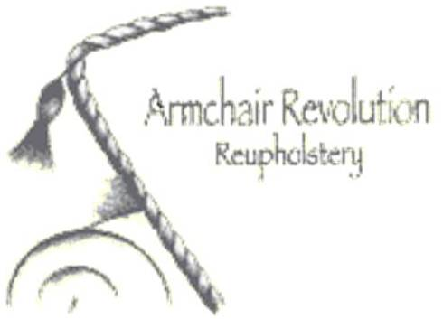

#### TESTIMONIALS ...

#### [Exceptional wor](http://homestars.com/reviews/57890?company_id=195793)k

[*Kathryn Busch in Orangeville*](http://homestars.com/homeowner/55891-kathryn-busch-in-orangeville)

**Smoking Chair Upholstery** We had an old antique smoking chair in our basement without any upholstery for as long as I can remember. I brought it to Armchair Revolution and finally got to see it completed. The work was great and done very quickly and at a good price (lower than the quote!). I'd definitely bring back more furniture and recommend them to friends.

#### Extremely Happy

*Bri-Anne, Mississauga*

**Re-upholstery** I recently got a 1960's wood frame armchair and ottoman re-upholstered at Armchair Revolution and I couldn't be happier.   
Barbara was extremely helpful from start to finish. They were extremely flexible with my drop off and pick up times. Barbara also supplied endless choices of fabrics, and after a lot of debate and even bringing samples home, the final product looks stunning, they even restored the wood!   
I would definitely use their services again!

#### Amazing Work

*Tanya, Toronto*

**Antique couch** We had an antique couch from the 1800's that needed a face lift and serious help with the internal springs. Barbara maintained the integrity of bones of this couch, fixed all the springs, added a bit more cushioning to make it nicer to sit on again and polished up the wood. The couch has never looked so beautiful and her attention to detail on the piping is spectacular! We are so thrilled with the work they did and she even made us 2 little pillows to finish the look! Every day I walk into my house I love the couch more and more. I am a very fussy person when it comes to this kind of stuff and I inspected every corner of her work and it was perfect! Will definitely use them again!

#### Armchair Revived

*Jamie from East York*

**Reupholstered armchair and stool** Working with Armchair Revolution brought our old family armchair back to life. Barbara was knowledgeable and extremely helpful in suggesting fabrics, working within our price range and providing options. It was thrilling to see the final result. Without a doubt, we'd work with her again.





#### TESTIMONIALS ...

#### Exquisite reupholstery job by Armchair Revolution

*Iveta and Larry from Mimico*

**Armchair Reupholstery** We were extremely pleased with the choice of fabric, friendly service and workmanship. Our armchairs look exquisite and feel better than when they were new. We highly recommend Armchair Revolution to anybody who is considering having their furniture reupholstered.

#### Leather Reupholstery

*Sarah from Toronto*

**Chair and a Half Reupholstery in Leather** Barbara reupholstered a huge chair and a half in leather for me. She worked with me to pick the leather and priced out all the different options for me. The result is spectacular - a really beautiful piece! She worked within our budget by using faux leather on the sides and back of the chair and the match is incredible. The chair has beautiful stitching details and is a perfect match to compliment our ottoman - right down to the feet on the chair. I would use Armchair Revolution again in a heartbeat.

#### Armchair Revolution Was A Pleasure To Deal With

*Michelle from Oakville*

**Reupholstering of a Chair and a Half** I have used Armchair Revolution in the past and had such good results last time, they were the first that came to mind for my new project. My piece came back to me better than I expected, and with some really lovely personal touches as well. I would definitely use them again, and would recommend them to anyone looking for a service such as theirs.

#### Armchair Revolution is creative and professional

*Jan from King City*

**Reupholstery of several unusual antique chairs** Barbara and Debbie were delightful and easy to work with. The restoration of the wood in the antique chairs was professional and the result beautiful. The re-upholstery of the seats of the chairs and settee rendered them much more comfortable than before.





#### TESTIMONIALS ...

#### Perfection at Work

*Faith from Parkdale*

**Cushions, Blinds, Couch Futon Cover, Dining Chairs** The work produced by this company is nothing short of perfection. Fine, fine work with an eye for colour and detail that is original and creative. I have recommended Barbara at Armchair Revolution to many of my friends, and everybody, without exception has thanked me profusely for the referral.

#### Re-upholster with confidence in Armchair Revolution

*Nancy, south Etobicoke*

**Antique chesterfield and easy chair re-upholstery** Barb and Debbie of Armchair Revolution have a solid reputation for skillfully giving new life to tired and worn furniture. They are a pleasure to work with and I have confidently referred many friends, neighbours and colleagues to them over the years.

#### Our couch was sagging terribly...

*Denise, in Etobicoke*

**New webbing on couch** I had heard it was difficult to get the webbing replaced and when I called the original manufacturer, they could not help. Then I called Armchair Revolution. They came, looked at the couch, suggested a solution and did great job. I got the feeling they cared about the quality as much as I did.

#### Armchair Revolution Reupholstery - Revolutionary Customer Service!

*Patrick from Etobicoke*

**Various Upholstery Projects (over many years)** Barb and Debbie are amazing. Always skilled, efficient and helpful. They really work hard to make every client happy. (And it also doesn't hurt that they both have terrific senses of humour.)